AI ASSISTED CODING
ASSIGNMENT 2.2
NAME : G.Harshavardhan
HALLTICKET.NO : 2403A52313
BATCH.NO : 01 YR AND SEM : 2ND AND 3RD

TASK DESCRIPTION 1:
QUESTION:
Use Gemini in Colab to write a func on that filters out all nega ve numbers from a given list
PROMPT:
write a code in python in which input of list is taken from user and create a func on which separates the nega ve numbers from list and return filtered list
EXPECTED OUTPUT:
Func onal code with before/a er input and output shown in Colab, plus a screenshot CODE WITH OUTPUT:
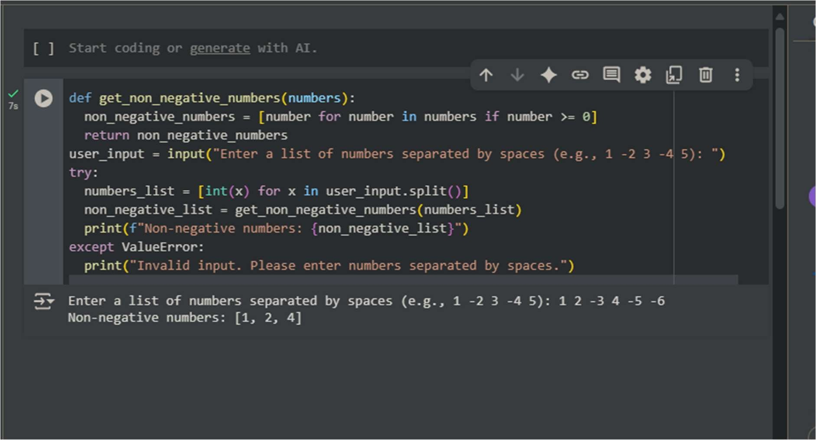

OBSERVATION: IT IS OBSERVED THAT CODE IS GENERATED WITH NO TIME AND WITH BETTER OUTPUT
EXPLAINATION:
This code takes a list of numbers entered by the user, separates them into nega ve and nonnega ve numbers, and then prints both lists.

TASK DESCRIPTION 2:
QUESTION:
Ask Gemini to generate code that reads a text file and counts the frequency of each word. Then ask it to explain the code
PROMPT:
generate code in python that reads a text file and counts the frequency of each word
EXPECTED OUTPUT:
Working code and Gemini’s explana on side-by-side
CODE WITH OUTPUT:

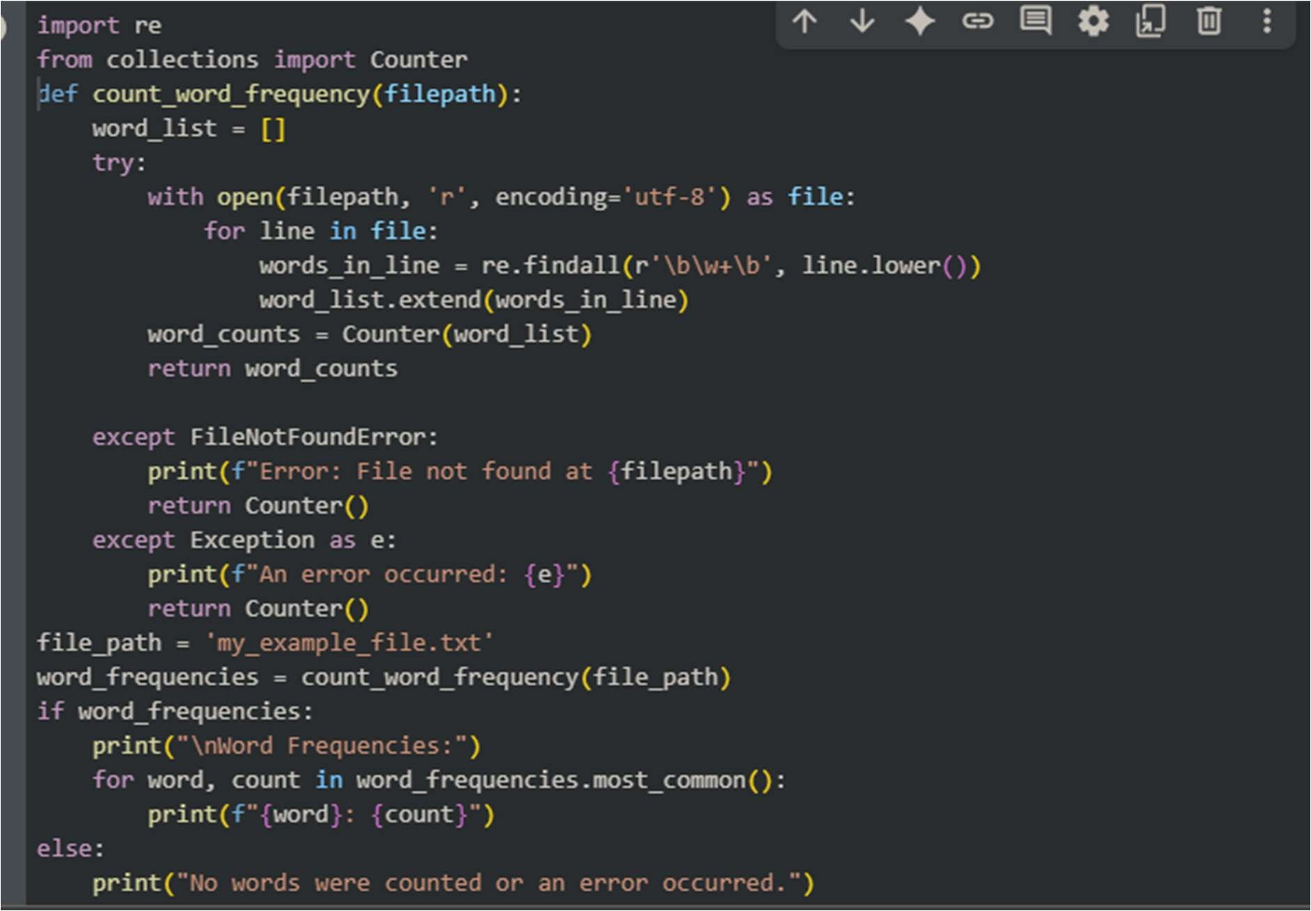
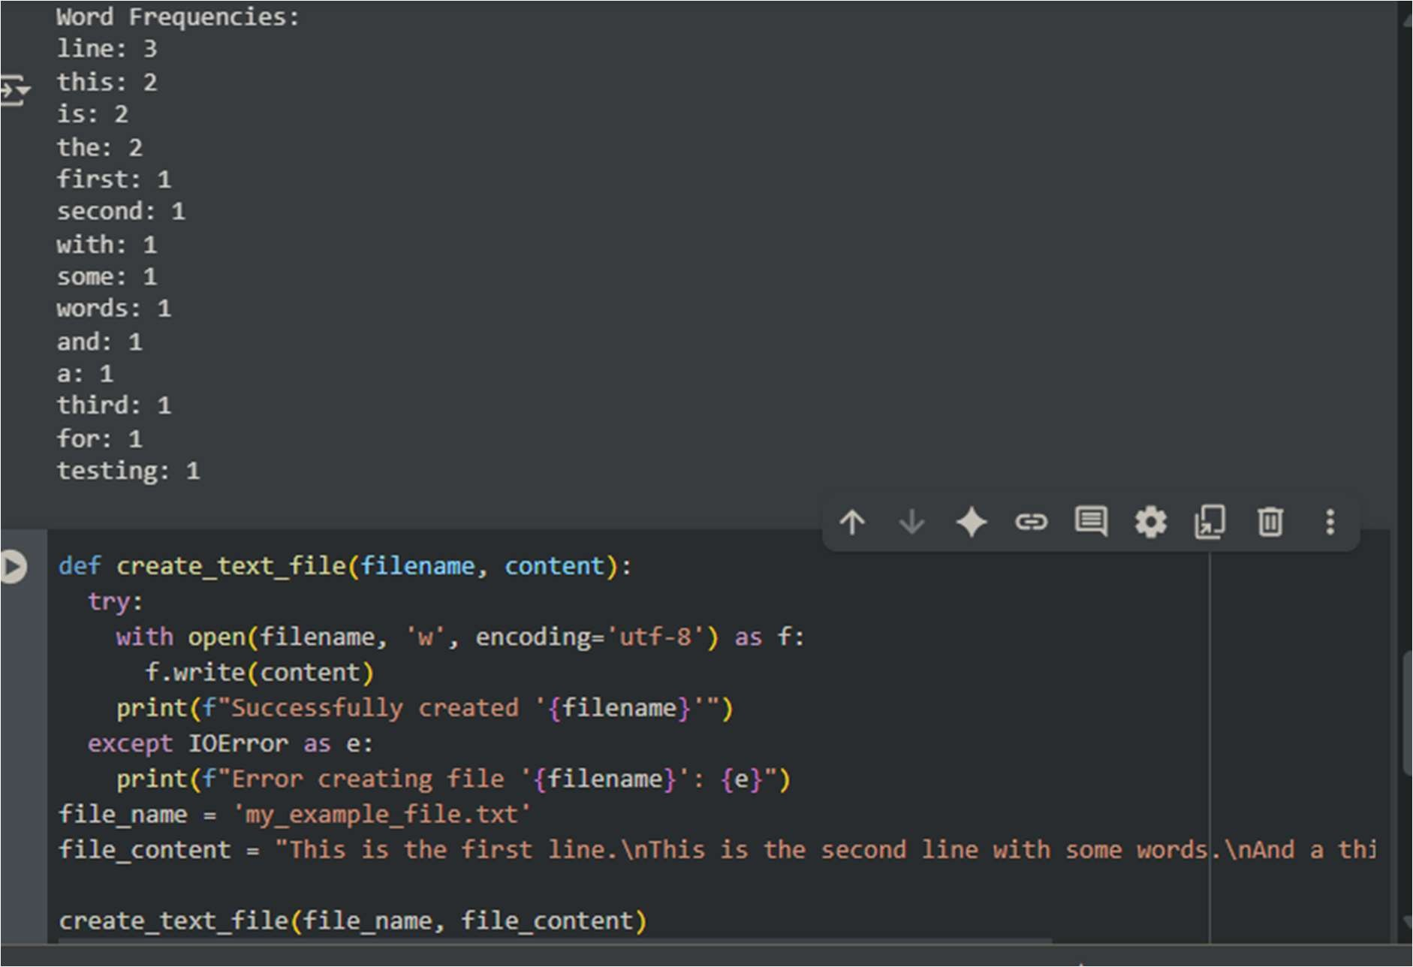
OBSERVATION:
The provided code is a good balance of simplicity and efficiency for crea ng a text file and coun ng word frequencies. It uses standard, well-op mized Python libraries and techniques. While more advanced methods exist for handling truly massive datasets, this code is efficient and perfectly suitable for many common text processing tasks.
EXPLAINATION:
In summary, this code provides a robust way to read a text file, extract words, and count how
many mes each word appears, handling poten al file-related errors.
TASK DESCRIPTION 3:
QUESTION:
Use Cursor AI to generate a Python class called Book with a ributes tle, author, and a method summary() that prints the details.
PROMPT IN GEMINI:
generate a code in Python class called Book with a ributes tle, author, and a method summary() that prints the details.
EXPECTED OUTPUT:
Screenshot comparisons and student commentary on code clarity and performance
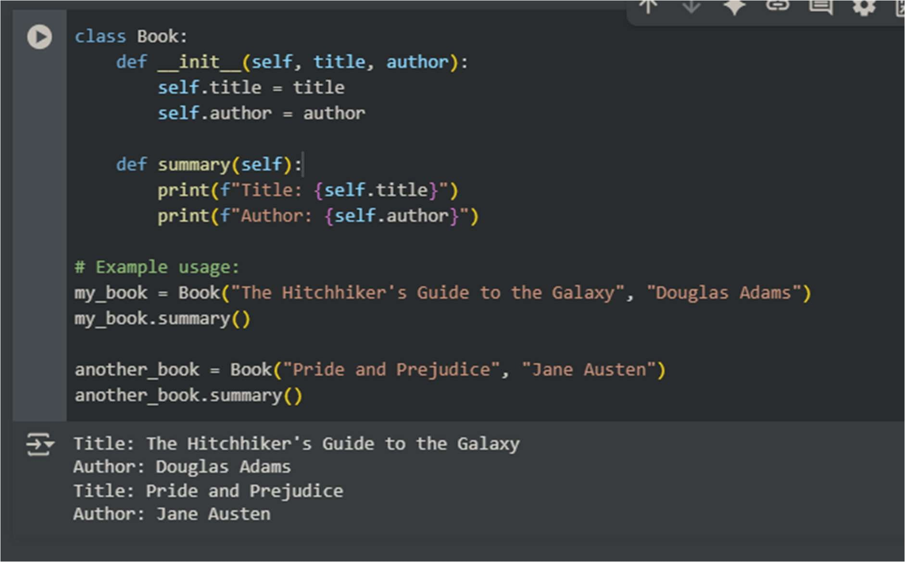

PROMPT IN COPILOT:
generate a code in Python class called Book with a ributes tle, author, and a method summary() that prints the details.
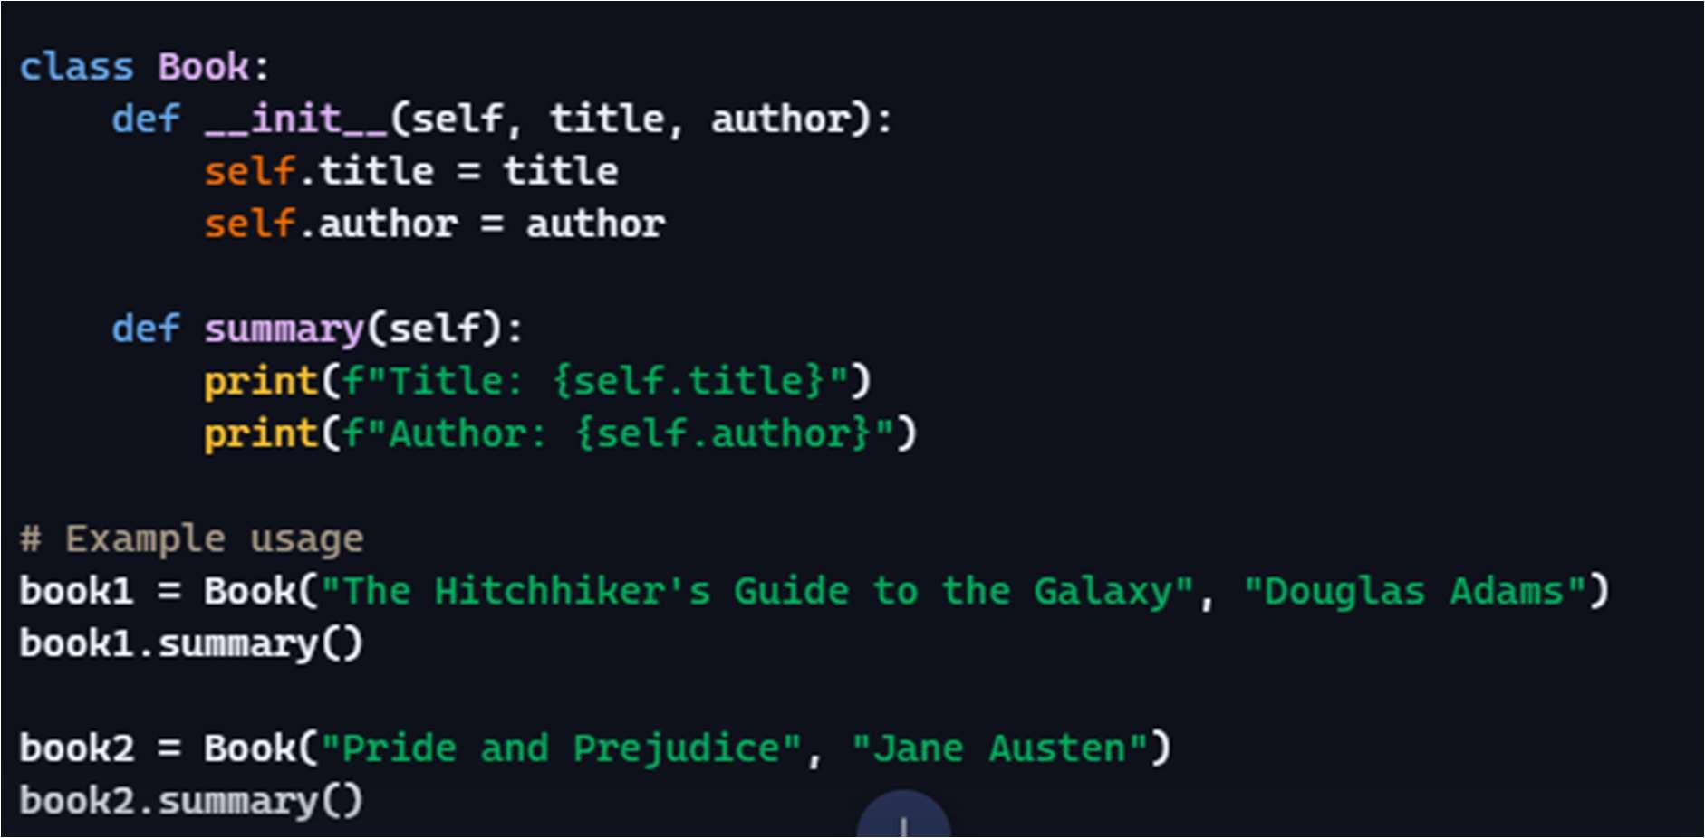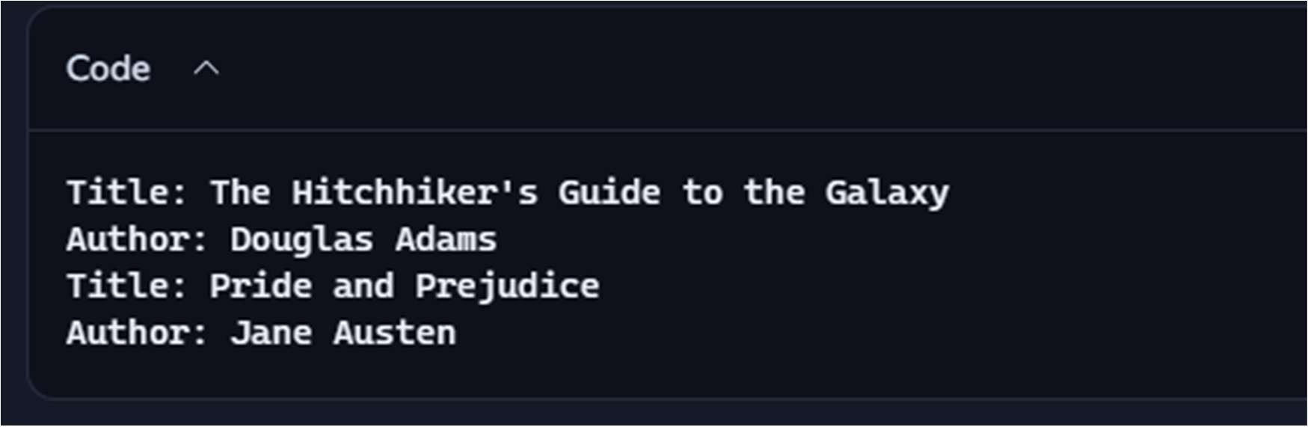

COMMENTRY ON CODE CLARITY AND PERFORMANCE:
- Clarity: COPILOT’s code is like a simple, well-wri en instruc on manual. I can quickly understand how to make a "book" object and get its basic informa on. There are no confusing steps or jargon.
- Performance: It's like a lightning-fast li le machine. When I ask it to create a book or tell you it’s summary, it does it almost instantly without breaking a sweat. It's not doing any unnecessary work.
EXPLAINATION:
- This code defines a template for crea ng "Book" objects, each holding its own tle and author, and provides a way to display that informa on.

TASK DESCRIPTION 4:
QUESTION:
Ask Gemini to write a program that checks whether a number is an Armstrong number, and then modify it using Cursor AI to improve performance or structure EXPECTED OUTPUT:
Two versions of the code with screenshots, and a summary of what changes were made by Cursor. PROMPT IN GEMINI:
generate a code when a number is given it should check whether a number is an Armstrong number
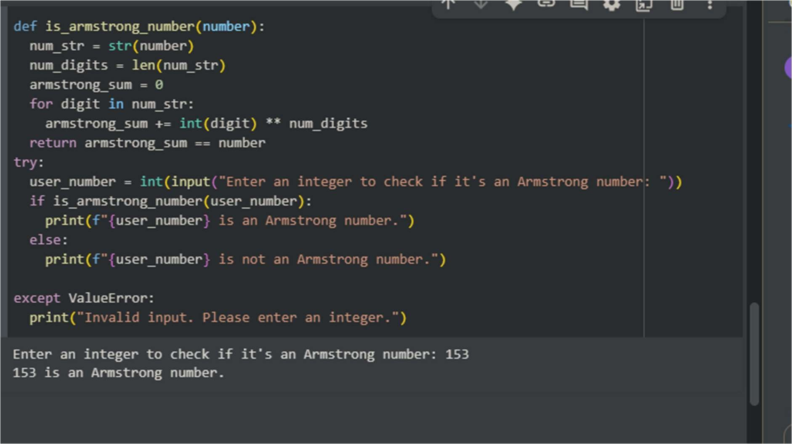
PROMPT IN COPILOT:
generate a code when a number is given it should check whether a number is an Armstrong number

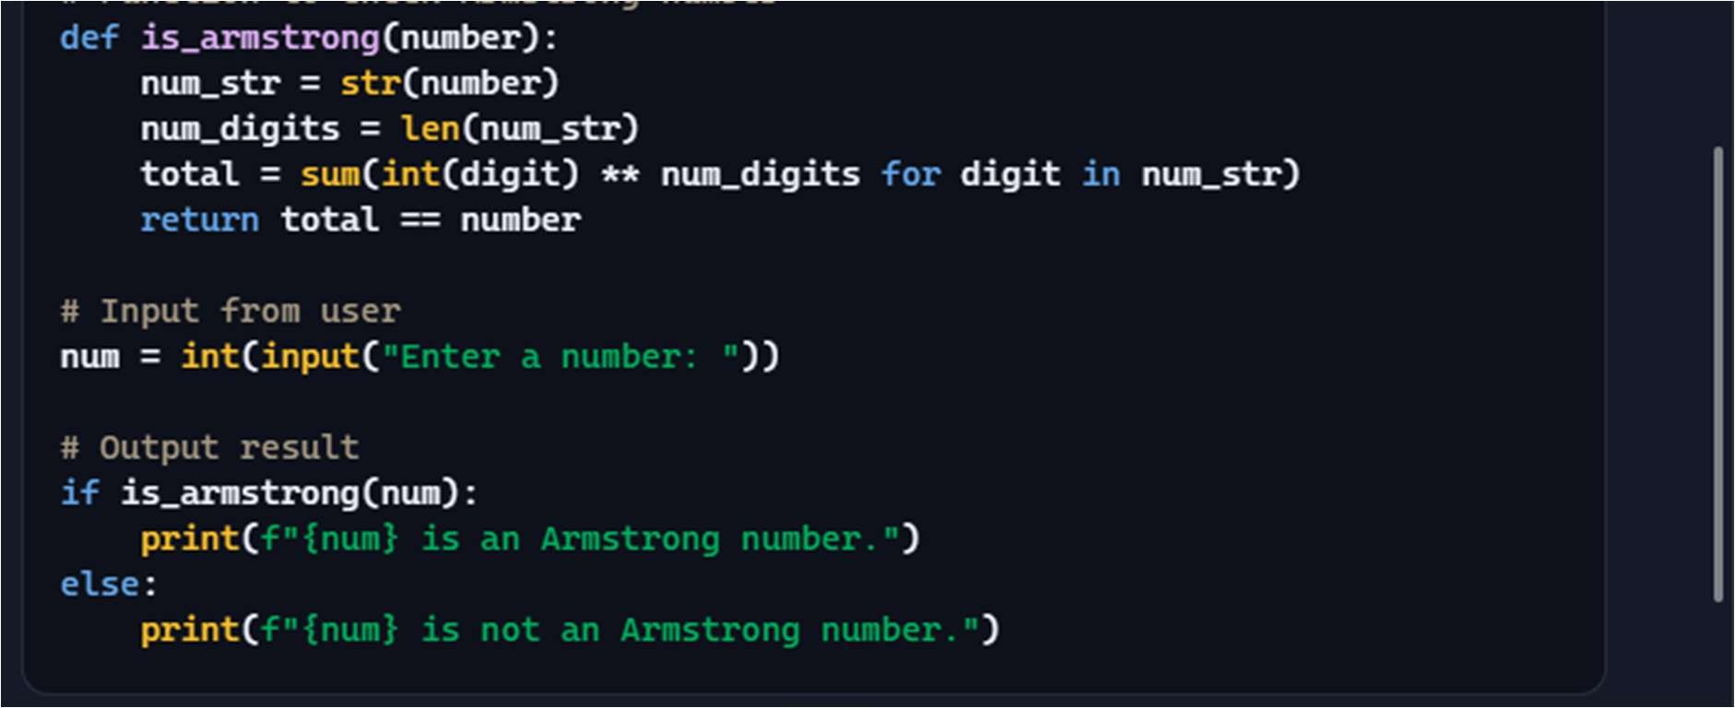
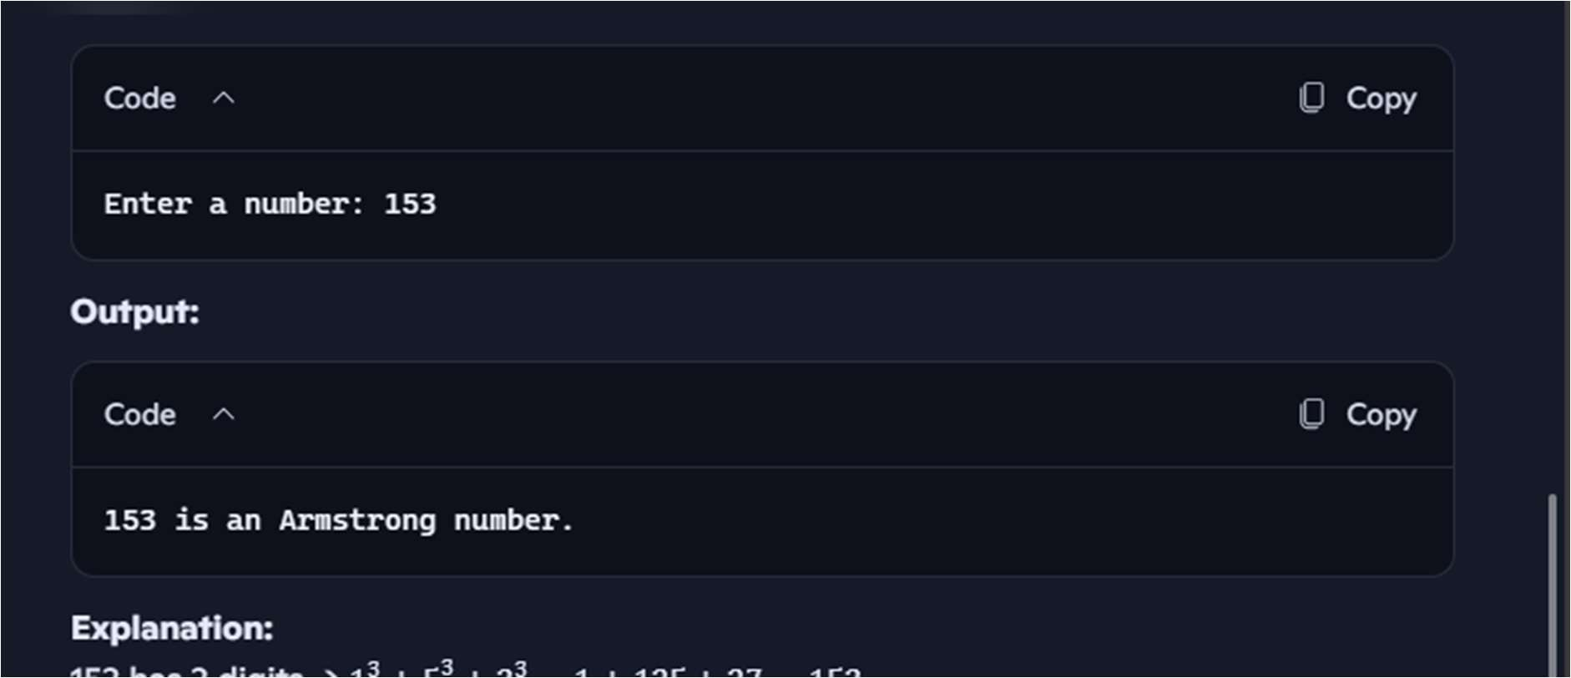
SUMMARY:
- Clarity: COPILOT’s code is like a clear recipe for checking Armstrong numbers. Most of the steps are obvious, and even the slightly more compact calcula on step is a common way to do things efficiently in Python.
- Performance: It's like a quick li le calculator for this specific job. For the numbers you'd usually test, it gives you the answer almost instantly. It handles bigger numbers gracefully; it just takes a ny bit longer as the number gets longer, but it's not like it suddenly grinds to a halt. For performance it is Gemini AI which performed in very good manner.

TASK DESCRIPTION 5:
QUESTION:
Use both Gemini and Cursor AI to generate code for sor ng a list of dic onaries by a specific key (e.g., age)
PROMPT IN GEMINI: generate a code for sor ng a list of dic onaries by a specific key.
EXPECTED OUTPUT:
Screenshot comparisons and student commentary on code clarity and performance CODE WITH OUTPUT IN GEMINI:
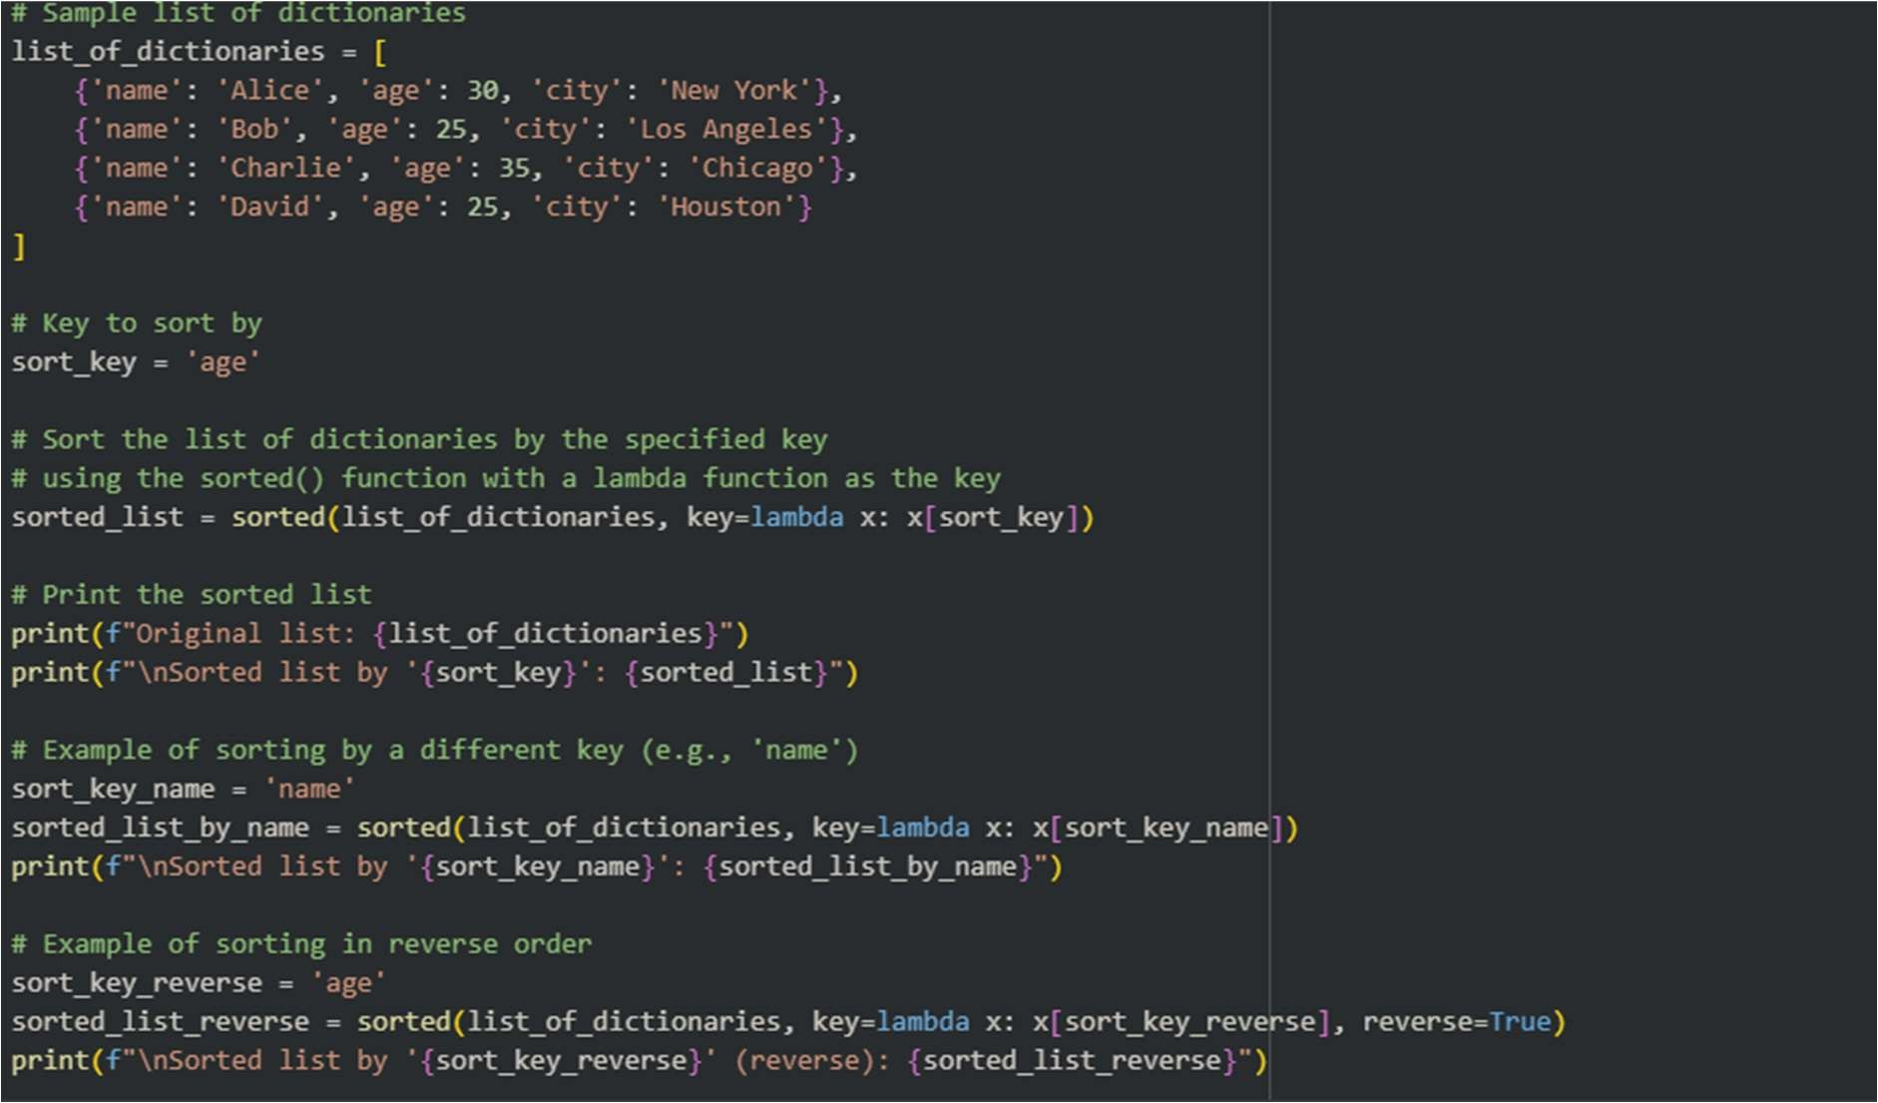
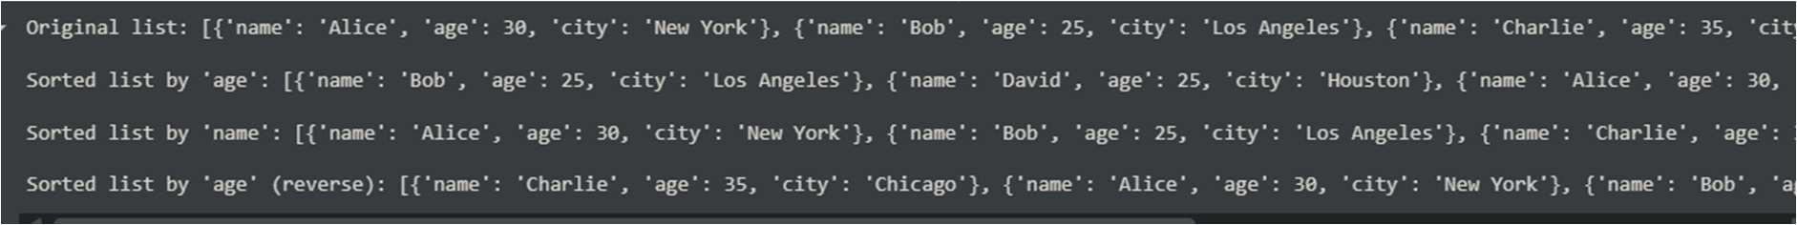
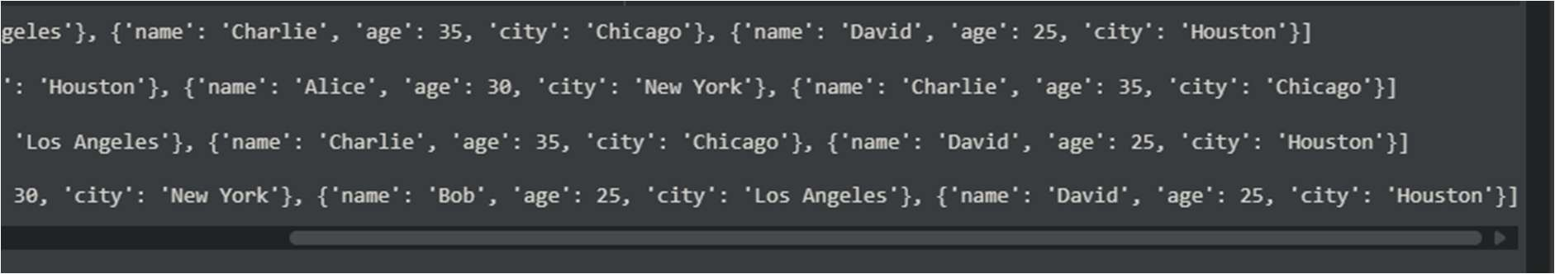

CODE AND OUTPUT WITH COPILOT:
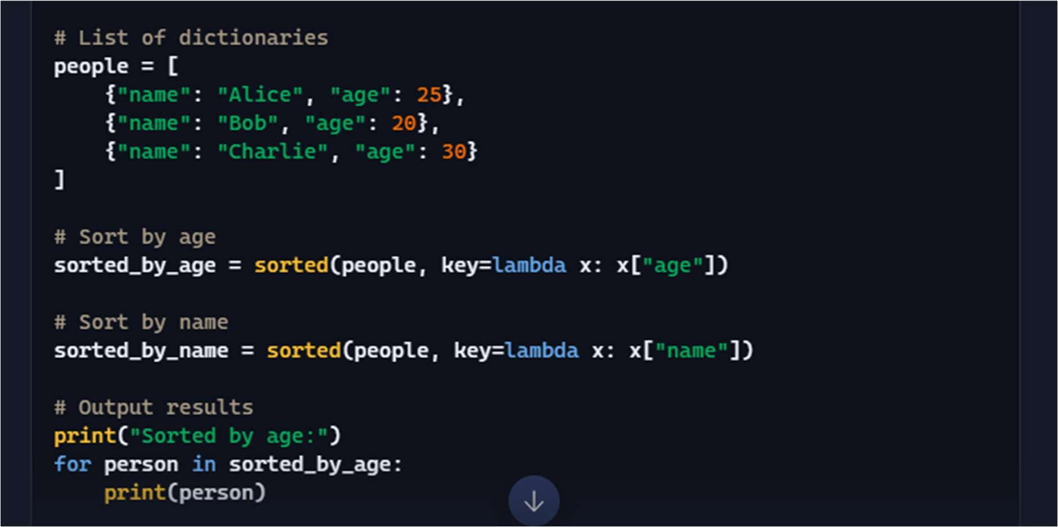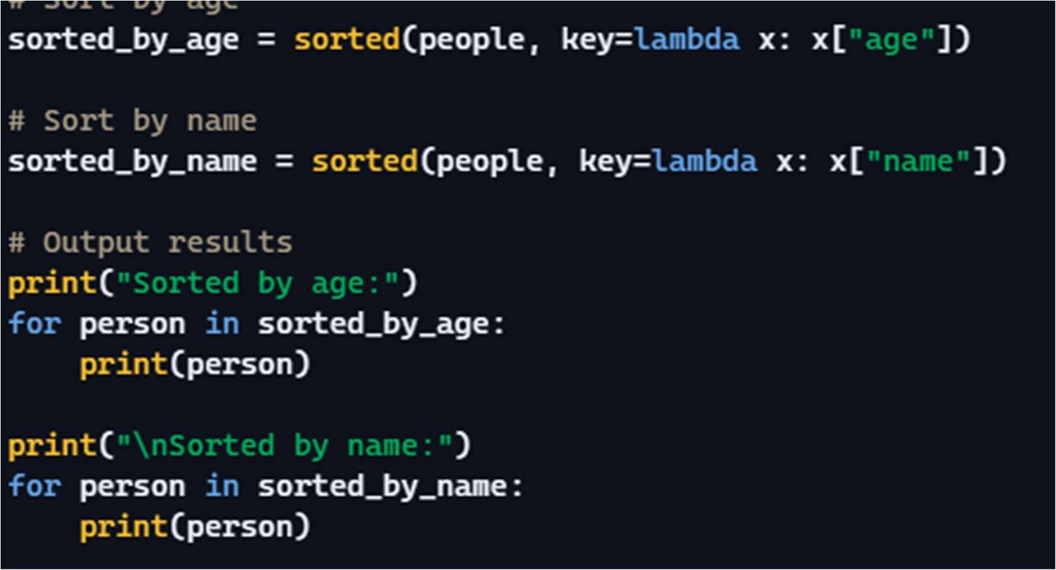

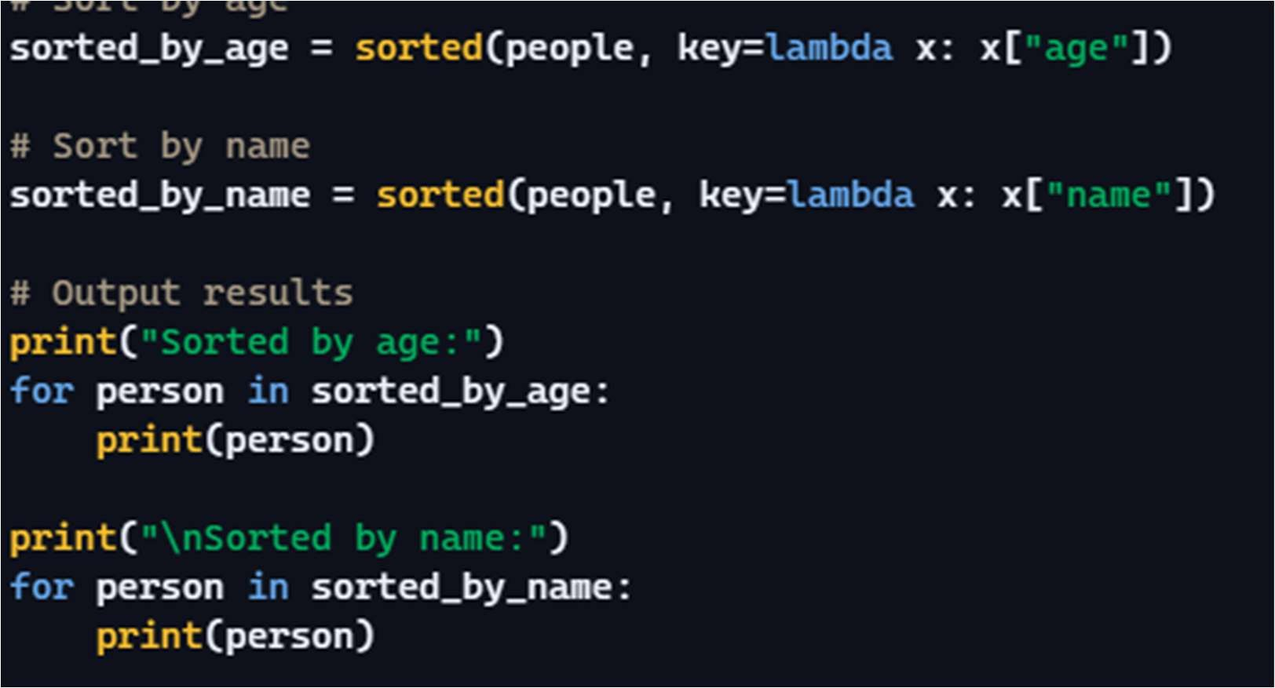

SUMMARY:
- Clarity: COPILOT is like having a simple instruc on: "Take this stack of papers (your list of dic onaries) and sort them based on the age wri en on each paper (the 'age' key)." It's direct and easy to follow. The lambda is just a quick way to peek at the right piece of informa on on each paper for sor ng.
- Performance: It's like having a really efficient sor ng machine. I give it the stack, and it quickly arranges them in the order I asked for, whether it's by age or name. It doesn't waste me and can handle quite a few papers before slowing down no ceably.

